ASSIGNMENT 2 (CO2)
Programme: B. Tech Biotechnology
Course Code: CSA0232
Course Name: C Programming
Submitted by: MAVES TEFFANY
Register Number: 192522056
Faculty: Dr . NATTAR KANNAN
Slot: C
GitHub Repository: https://github.com/192522056simats-commits/CSA0203-SLOTC.git

TASK 1
Aim - To analyse operator precedence and associativity in C and identify errors in pharmacy billing calculations involving arithmetic and conditional operators.
Operator Precedence and Associativity
The operators are evaluated in the following order:
- Multiplication (*) and division (/) have higher precedence.
- Multiplication and division are evaluated from left to right.
- Addition (+) and subtraction (-) are evaluated after multiplication and division.
- Relational operator (>) is evaluated before the conditional operator (?:).
- The conditional operator selects the appropriate result based on the condition.

SOURCE CODE
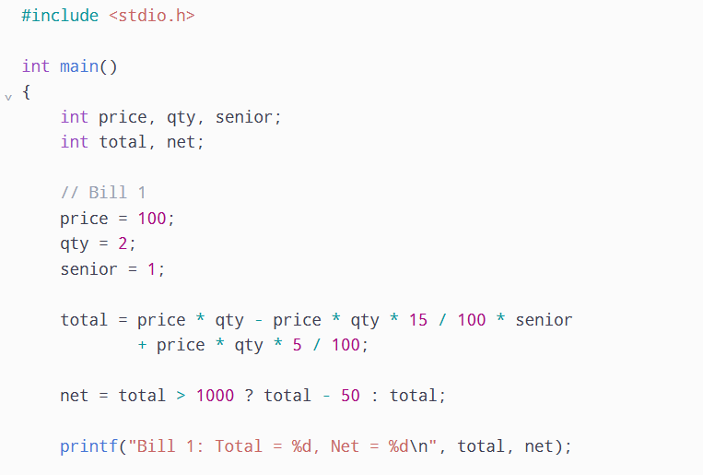
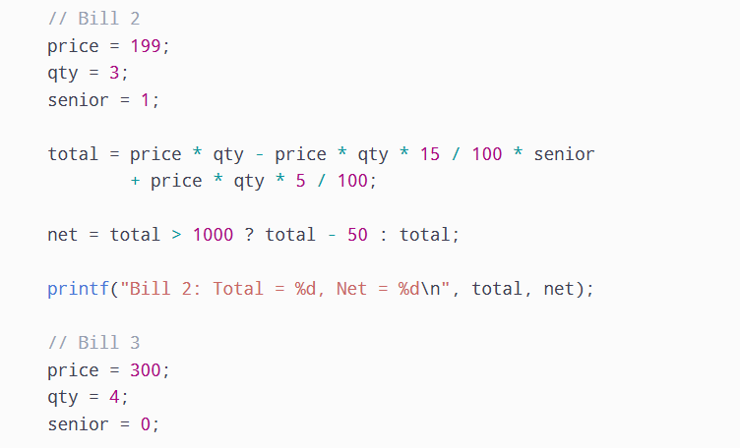
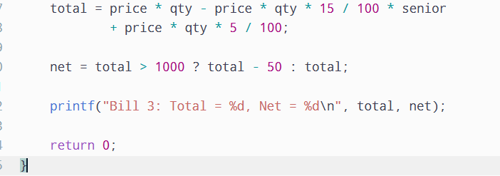
OUTPUT
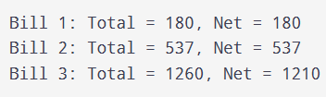

Identification of Errors
Integer Division: In C, integer division removes the decimal part of the result.
For example:
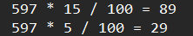
The actual values are 89.55 and 29.85. Therefore, the original expression loses decimal precision.
Undefined Behaviour:
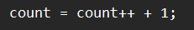
This statement causes undefined behaviour because count is modified more than once without proper sequencing. When compiled using -Wall, the compiler may display a warning about the operation on count possibly being undefined.

The correct statement is:
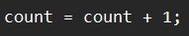
Corrected Calculation
To avoid integer division and improve readability, intermediate variables and floating-point calculations can be used.
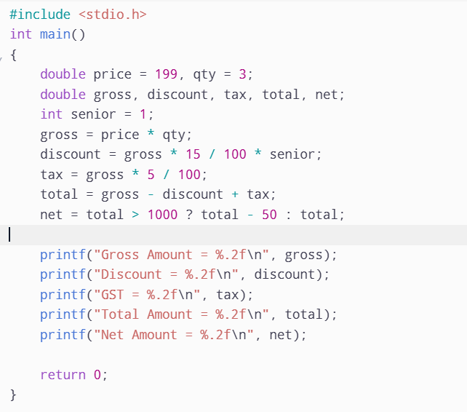
OUTPUT
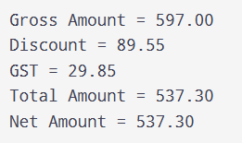
Conclusion
Thus, the program demonstrates operator precedence and associativity in C. Integer division can cause incorrect billing amounts by removing decimal values. Using intermediate variables, floating-point calculations and proper parentheses makes the program more accurate, readable and reliable.

TASK 2
Aim - To understand short-circuit evaluation in C using logical AND (&&) and logical OR (||) operators and analyse how the order of conditions affects function calls.
SOURCE CODE
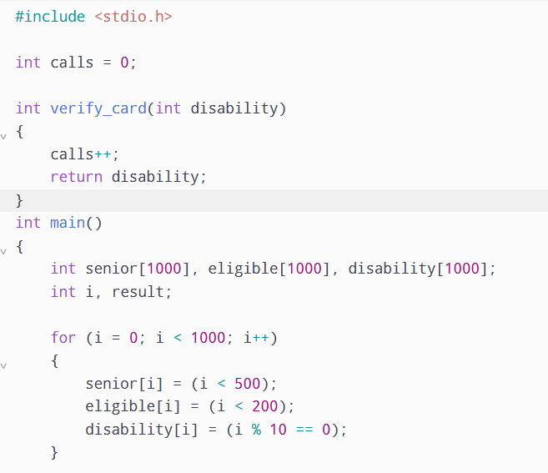
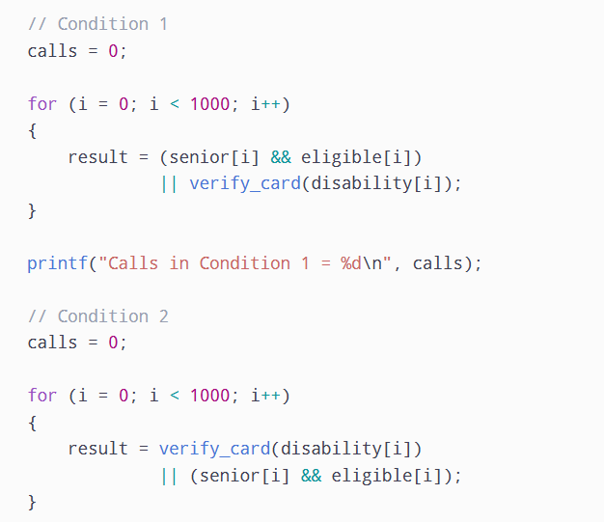
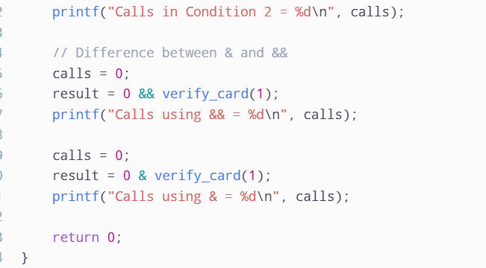

OUTPUT
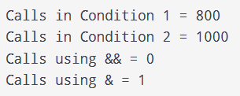

Conclusion
Thus, short-circuit evaluation reduces unnecessary function calls and improves program efficiency. The && and || operators avoid evaluating the second operand whenever the result is already determined. Nested if statements can also achieve this behaviour, whereas bitwise operators evaluate both operands. When audit logging is required, every passenger must be verified.

TASK 3
Aim - To implement device ON/OFF operations using bitwise operators in C and store the status of multiple devices in a single unsigned char variable.

SOURCE CODE
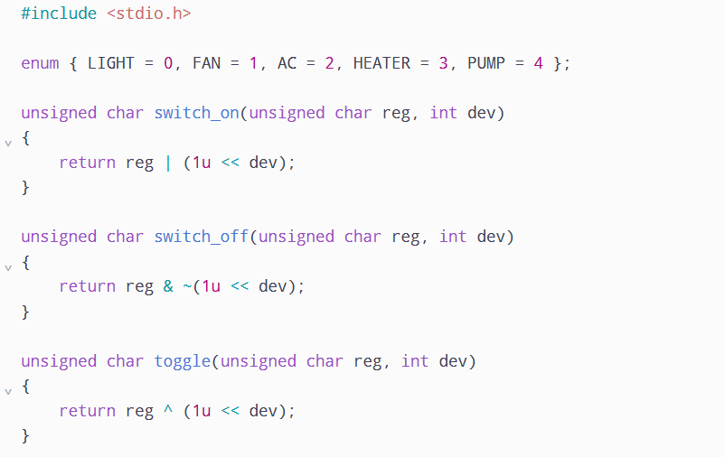
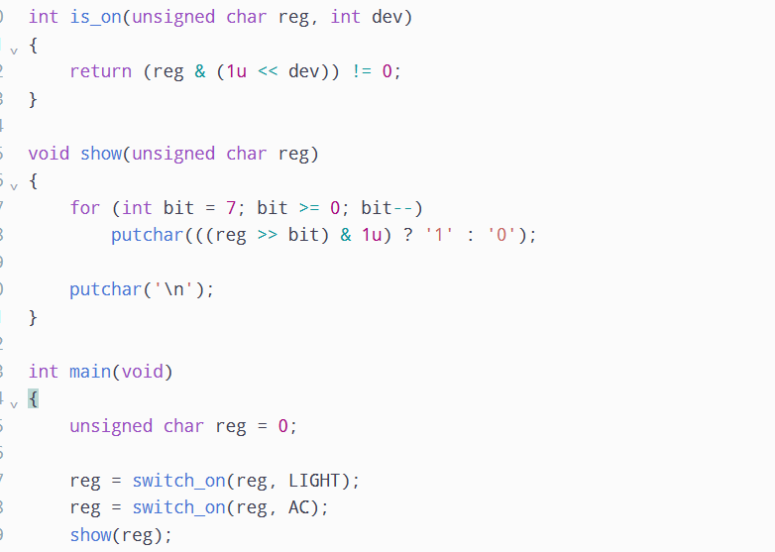
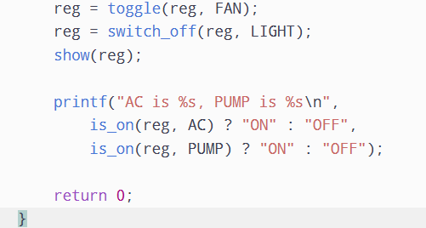

OUTPUT
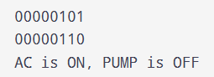

Conclusion
Thus, bitwise operators are used to control multiple device states efficiently using a single unsigned char variable. This method reduces memory usage and performs ON, OFF, toggle and status-checking operations in constant time.

TASK 4
Aim - To implement grade classification using an else-if ladder and switch statement in C and analyse their behaviour, boundary conditions and differences.
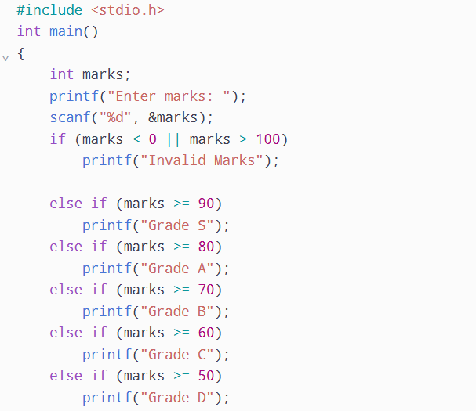
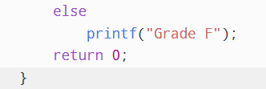

OUTPUT


Conclusion
Thus, both else-if ladder and switch statements can be used for grade classification in C. The else-if ladder is suitable for range-based conditions, whereas switch is useful for fixed values. A lookup table is another efficient alternative for grade classification.

TASK 5
Aim - To implement prime number checking using different looping constructs in C and compare the number of divisions performed by the normal and optimized methods.
SOURCE CODE
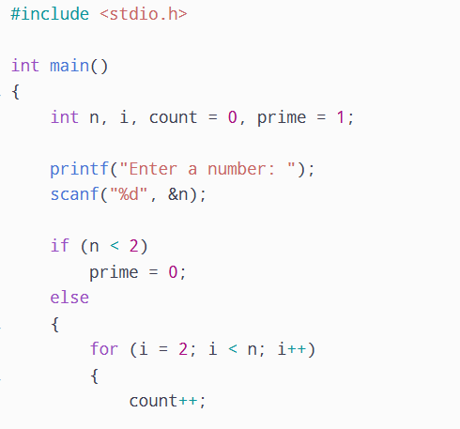
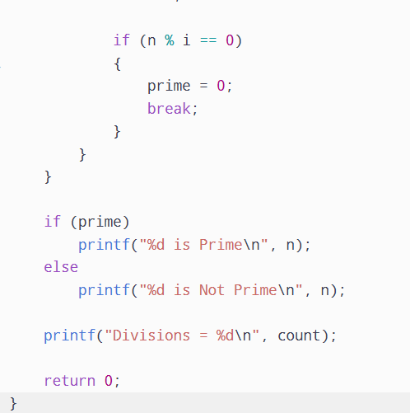
OUTPUT
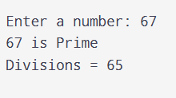
Conclusion
A do-while loop executes at least once. For 2 and 3, there are no divisors to check, so the program must handle these cases carefully to avoid unnecessary division checks.

TASK 6
Aim - To develop a C program that calculates a month-by-month loan repayment schedule using looping constructs and determines the total interest paid and number of months required to repay the loan.

SOURCE CODE
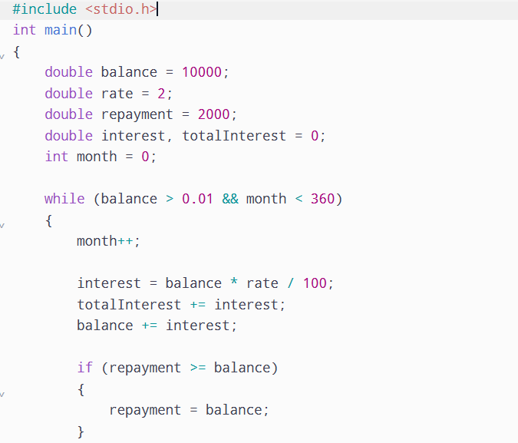
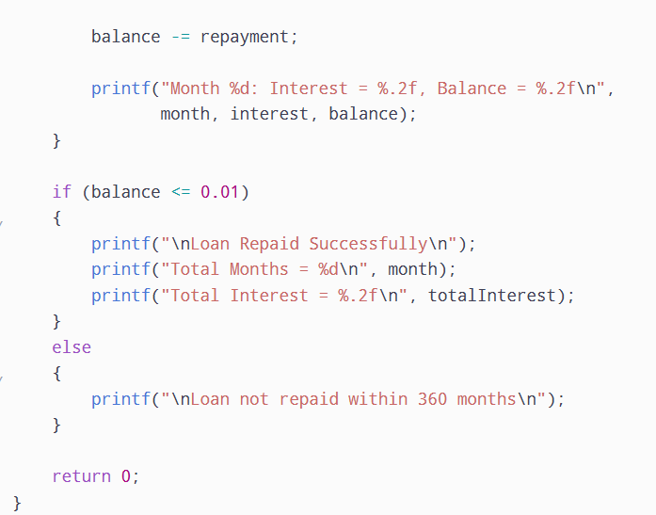

OUTPUT
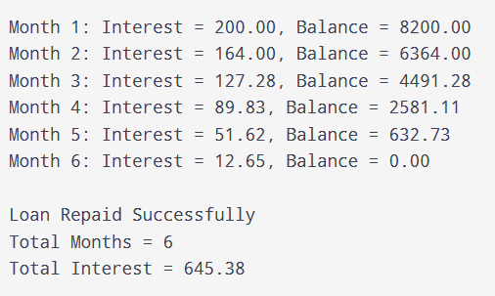
Conclusion
Thus, the loan repayment program demonstrates the use of while loops, conditional statements and break conditions in C. It calculates monthly interest, repayment amounts and the total interest paid. A safety limit and proper termination condition help prevent infinite loops and ensure reliable execution.

TASK 7
Diagnose the Bottleneck
The original prime number checking program tests every divisor from 2 up to the square root of the given number. The main limitation is that it checks both even and odd divisors, even though every even number greater than 2 is not a prime number.
Identified problems:
- Unnecessary division operations increase execution time.
- Checking even divisors after 2 wastes computational resources.
- The number of divisions increases as the input number becomes larger.

The objective is to reduce the number of division operations without affecting the correctness of prime number checking.
The redesigned program will:
- Check whether the number is divisible by 2 first.
- Skip all even divisors after 2.
- Check only odd divisors starting from 3.
- Stop checking when the divisor exceeds the square root of the number.

Design the Revised Solution
Proposed Algorithm:
Read the input number.
If the number is less than 2, it is not prime.
If the number is 2, it is prime.
If the number is divisible by 2, it is not prime.
Start checking odd divisors from 3.
Increase the divisor by 2 after each iteration.
If a divisor is found, stop the loop.
Otherwise, declare the number as prime.

PSEUDOCODE:
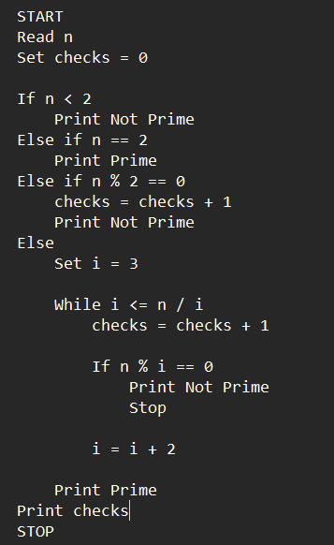

Predict Before Implementing
Before implementing the redesigned program, I predict that skipping even divisors will reduce the number of division operations by approximately half for large prime numbers.
The program will maintain the same output for prime and non-prime numbers.

SOURCE CODE
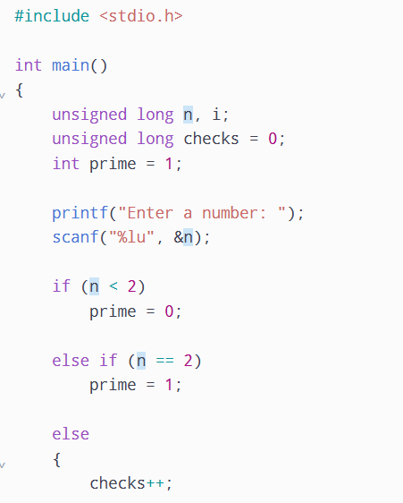
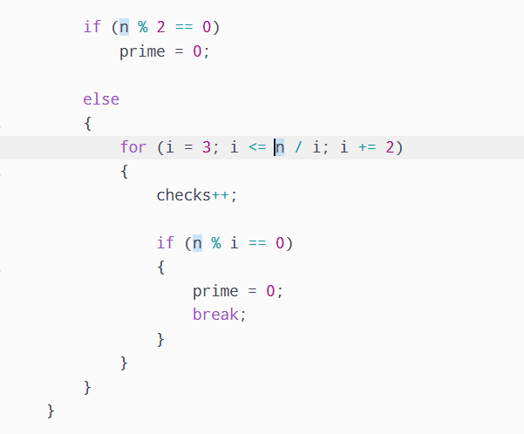
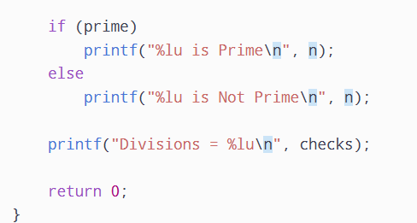

OUTPUT
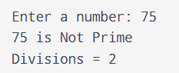

Conclusion
Thus, the prime number checking program was successfully redesigned by skipping unnecessary even divisors. The redesigned solution reduced the number of divisor checks by approximately 50% for large prime numbers while maintaining the same correctness.
This demonstrates how analysing an existing algorithm and improving its design can increase computational efficiency without changing its overall purpose.

